2022年广东省初中学业水平考试
英语试卷

机密★启用前

2022年广东省初中学业水平考试
英语

说明:
1. 全卷共10页,满分为120分,考试用时为100分钟。
答卷前,考生务必用黑色字迹的签字笔或钢笔在答题卡填写自己的准考证号、姓名、考场号、座位号。用2B铅笔把对应该号码的标号涂黑。
选择题每小题选出答案后,用2B铅笔把答题卡上对应题目选项的答案信息点涂黑,如需改动,用橡皮擦干净后,再选涂其他答案,答案不能答在试题上。
非选择题必须用黑色字迹钢笔或签字笔作答,答案必须写在答题卡各题目指定区域内相应位置上;如需改动,先划掉原来的答案,然后再写上新的答案；不准使用铅笔和涂改液。不按以上要求作答的答案无效。
考生务必保持答题卡的整洁。考试结时,将试卷和答题卡一并交回。

- 听说应用 （本大题共30小题,每小题1分,共30分，分为A、B、C、D部分为听力理解，E部分为情景对话）
A. 听句子（本题共5小题，每小题1分，共5分）
请根据所听内容，选择符合题意的图画回答问题，并将答题卡上对应题目所选的选项涂黑。每个句子听两遍。
1. What did the girl draw?
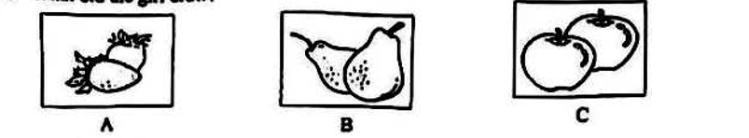

2. Which is the sign?
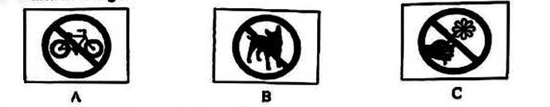

3. How did the speaker spend the morning?

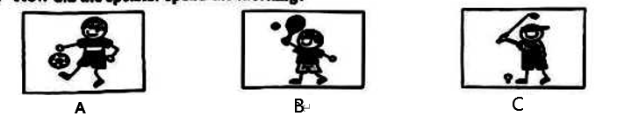
4. Which picture is the speaker talking about?
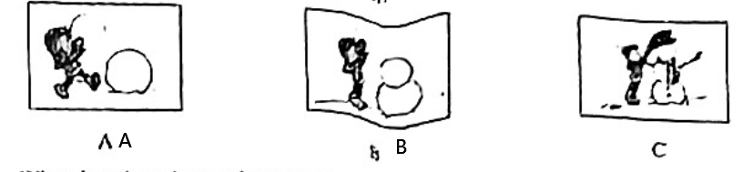
5. What time does the speaker get up on weekends?
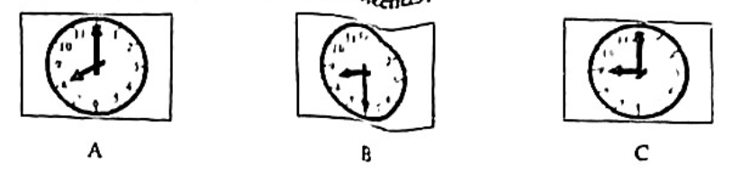

B. 听对话（本题共10小题，每小题1分，共10分）
请根据每段对话的内容回答问题，从每小题所给的三个选项中选出一个最佳答案，并将答题卡上对应题目所选的选项涂黑。每段对话听两遍。

听第一段对话，回答第6小题。
6. What is Jenny doing?
A. Washing her face. B. Having breakfast. C. Brushing her teeth.
听第二段对话，回答第7小题。
7. Who took the umbrella?
A. Jim. B. Sam. C. The woman.
听第三段对话，回答第8小题。
8. Where does Jack want to go?
A. To the cinema. B. To the bank. C. To the zoo.
听第四段对话，回答第9小题。
9. What is the man’s job?
A. A taxi driver. B. A waiter. C. A teacher.
听第五段对话，回答第10小题。
10. What are they talking about?
A. A new home. B. A broken window. C. A big bed.
听第六段对话，回答第11-12小题。
11. What is wrong with the man’s computer?
A. It wouldn’t start. B. It has no sound. C. It is too old.
12. What is the woman going to do?
A. To buy a computer. B. To fix the computer. C. To borrow.
听第七段对话，回答第13-15小题。
13. How does Kevin usually travel?
A. By air. B. By ship. C. By train.
14. When will the girl go to Kunming?
A. This spring. B. This summer. C. This autumn.
15. Who will go with the girl?
A. Her father. B. Her friends. C. Her mother.

C. 听短文（本题共5小题。每小题1分，共5分）
请根据所听内容，从每小题所给的三个选项中选出一个最佳答案，并将答题卡上对应题目所选的选项涂黑。短文听两遍。
16. What did Jason’s mother do every night?
A. She read him stories. B. She made him clothes. C. She taught him English.
17. What happened to Jason when he was 12?
A. He got hit by a truck. B. He dropped out of school. C. He lost his books.
18. Where did Jason find some books one night?
A. In a room. B. By the road. C. In a library.
19. How many books has Jason collected?
A. About 20,000. B. About 2,000. C. About 200.
20. When is the small library open?
A. Every evening. B. Every afternoon. C. Every weekend.

D. 听填信息（本题共5小题，每小题1分，共5分）
你将听到一则设计活动的介绍。请你根据所听内容填写下面的信息卡，并将答案写在答题卡对应题目的答题位置上。短文听两遍。
T-shirt Design (设计) Wanted
Topic: saving the ______21______
Design: a ______22______ and some words
Important dates: to hand in before July 21st
to get the result on August _______23______
Prizes: to work with the magazine next ______24______ holiday
to get 100 ______25______ T-shirts for free

E. 情景对话（本题共5小题，每小题1分，共5分）
请通读下面对话，根据对话内容，从方框内的选项中选出能填入空白处的最佳选项，并将答题卡上对应题目所选的选项涂黑，选项中有一项为多余选项。
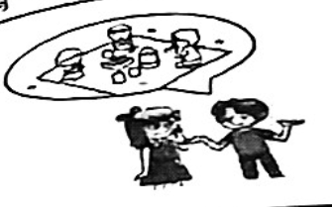
A. Really?
B. What about you?
C. Maybe next time.
D. The park near your home?
E. Have a good time.
F. Would you like to go with us?

Tom: What’s your plan tomorrow, Ann?
Ann: I’ll stay at home. ____26___
Tom: I will have a picnic in a park with some friends.
Ann: ___27___
Tom: No. We’ll go to Zhongshan Park.
Ann: Have you checked the weather report?
Tom: Yes. It’ll be sunny. ___28___
Ann: I’d love to, but I have to finish a school report.
Tom: What a pity! ___29___
Ann: OK. ___30___
Tom: Thank you.

二、语法选择（本大题共10小题，每小题1分，共10分）
请通读下面短文，掌握其大意，根据语法和上下文连贯的要求，从每小题3个选项中选出一个最佳的答案，并将答题卡对应题目所选的选项涂黑。
Wang Yiyi is an excellent Beijing Opera (京剧) artist. She was born and raised __31___ village in Hebei province. She loved singing and dancing ____32_____she was a little girl. She was her music __33__ favorite student. One day, the teacher told her _34__ a test. If she passed the test, she could enter a Beijing Opera school.
Wang Yiyi passed the test __35__ and became a student of that school. She worked ___36____……. Students in the school __37__ to get up at 6:45 a.m. to practice their basic……But she got up at 6:00 in the morning. And she was always the last one to go to bed. Sometimes she was tired that she felt like crying, she would find __38__ quiet place and cried aloud. She __39__ herself that she still had a long way to go and that she should keep practicing……
Years went by. Finally, __40__ hard work paid off. She got into a…… her life as a Beijing Opera actress.

31. A. in B. for C. with
32. A. if B. when C. because
33. A. teacher B. teachers C. teacher’s
34. A. take B. to take C. taking
35. A. success B. successful C. successfully
36. A. hard B. harder C. the hardest
37. A. ask B. asked C. were asked
38. A. a B. an C. the
39. A. tell B. tells C. told
40. A. she B. her C. hers

二、完形填空(本大题有10小题,每小题1分,共10分)
通该下面短文,掌握其大意,然后在每小题所给的四个选项中,选出一个最佳答案。并将答题卡对应题目所选的选项涂黑。
Almost every Saturday morning, Molly pulls a table into her front yard. On the table she lays out some ___41___in season, such as carrots and tomatoes. They are all from her garden and free for her neighbors to __42___. “It’s just lovely, like you walk by and get a beautiful gift around the corner,” said a neighbor.
Molly started doing this in the summer of 2020. Earlier that year, a fire broke out in her house. Molly’s__43___had a hard time. “People in the community came to __44___. They brought us food and often called to make sure we were doing fine. I was deeply__45___,” Molly said.
Then the pandemic(疫情) came. Molly and her family had much time to __46___ in their garden. They decided to __47___what they grew in their garden.
No one knew about it at first. But __48___, people got into the habit of coming around. They would stop by and leave with some vegetables. Molly ‘s yard became a __49___place.
One thing Molly has learned from this experience is that people have to work together when days are __50___ . She is glad that love has spread in this community.
41. A . fruits B . flowers C . leaves D . vegetables
42. A . look at B . take away C . give up D . throw away
43. A . family B . class C . office D . team
44. A . cry B . see C . help D . rest
45. A . moved B . interested C . tired D . bored
46. A . play B . work C . sleep D . dance
47. A . eat B . sell C . share D . cook
48. A . sadly B . slowly C . badly D . carefully
49. A . clean B . small C . terrible D . popular
50. A . difficult B . sunny C . short D . cool

- 阅读理解（本大题共15小题，每小题2分，共30分）
请阅读A、B两篇短文，从每小题所给的四个选项中选出能回答所提问题或完成所给句子的最佳答案，并将答题卡上对应题目所选的选项涂黑。
A
Imagine waking up to find a Cup of coffee ready and floor swept. With smart devices(装置) controlled by AI. All housework can be done while you are asleep.
Now your kids can try these devices at the small home, show in our community science center from August 1st to August 14th. Here in the center we have many fun activities. Children can also try out cleaning robot Little Q. It is a cute robot with a round head, two big eyes and two long legs. It’s like a big toy, Your children will love it.
Opening Hours: 1:00 p.m.- 9:00 p.m, from Tuesday to Sunday, closed on Monday.
Visitors: People of all ages are welcome. Children under 12 should come along with their parents. No pets are allowed.
Food & Drinks: No outside food or drinks. Visitors can buy food and drinks in the center.
Tickets: Please call 769520 to book a ticket. Kindly note that You CAN’T book a ticket
on our website or through e-mail. And it is NOT possible to buy a ticket at our ticket office as it is closed.

51. What can the smart devices in Paragraph 1do?
A. Farming. B. Business. C. Housework. D. Schoolwork
52. What does Little Q look like?
53. When can a visitor enter the science center?
A. On Monday morning, B. On Sunday morning.
C. On Monday afternoon. D. On Sunday afternoon
54. Who can be allowed to visit the center?
A. A man with a cat. B. An 8-year-old boy alone.
C. A man with his 3-year-old son. D. A girl with food from outside.
55. How can a visitor book a ticket?
A. By making a phone call. B. By sending an e-mail.
C. By visiting the website. D. By going to the ticket office.
B
Jerry is a world-famous mountain climber. He has climbed many high mountains in the world. Starting in 2015, he and his friends spent two years on an adventure（探险）in South America, covering 7,800 miles. He was even named Adventure of the Year by a famous geography magazine in 2018.
Although Jerry had achieved great success, he didn't feel fulfilled. He asked himself, “Is it enough to climb the highest mountains? Am I doing something helpful? How can I turn my adventures into something that can help the world?”
Jerry learned that scientists need plans, rocks and water samples（样本） from the places far away to do research. But scientists can’t get there themselves as such places are hard to reach——only the bravest adventurers can make it. Jerry thought himself could do something to help. He then came up with an idea. He set up a team of top adventures to collect samples for scientists. By studying the samples, scientists could know more about the earth and find ways to protect it.
Recently Jerry and his adventurer friends have discovered a special plant life of Mountain Qomolangma . The samples they brought back have helped scientists how plants live in extreme（极端的）condition.
For Jerry, this kind of adventure is most satisfying. “Such adventures had made us see life in a different way. Now, being the best climber isn’t important for me. what matters is doing something helpful while climbing the mountains. There is still much more we can do.” Jerry said to a newspaper.

- what is paragraph 1 mainly about?
- Jerry’s friends. B. Jerry's achievements.
C. High mountains. D. A geography magazine.
- what does the underline word “fulfilled” in paragraph2 mean?
- Satisfied B. lonely C. Patient D. Worried
- why did Jerry set a team of top adventures?
- To make friends. B. To help scientists.
C. To study plants. D. To train scientists.
- Jerry’s and his friends adventurers has changed_________.
- their hobbies. B. their friendship.
C.their understanding of life. D. their living conditions.
- Which can be the best title for the passage?
- Dangerous Mountains Climbing.
- Important Scientific Discoveries.
- Plants Found on High Mountains.
- Adventures Turned into Something Greater.

C
配对阅读。左栏是五则短信，右栏是七则回复。请将短信和回复进行匹配，并将答题卡上对应题目所选的选项涂黑。
61. Tara, could you buy some milk at the supermarket when you are back from school this afternoon?  62. Alice, I’m afraid I can’t join the shopping trip tomorrow. My cousin is coming to visit me.  63. Sorry, Tony. I missed the train and I’ll be late. If you get to the restaurant on time, could you please order orange juice and salad for me?  64. Hi, Peter. Has your leg got any better? We will have a match next week. Hope you can come and watch it!  65. Tom, the sports shop on West Street phoned. They have repaired your basketball shoes! | A. What a pity! Shall we meet sometime next week? After all, shopping won’t be fun without you.  B. We still have some in the kitchen. I bought a bottle of milk the day before yesterday and we haven’t opened it yet.  C. Great! I’ll collect them on my way to work tomorrow morning. Many thanks.  D. Sure. There is a fruit shop on my way home. What would you like me to buy? What about some bananas?  E. Take your time. I will be there in a few minutes. What salad would you like, fruit salad or vegetable salad?  F. You can take No.27 bus to my house. Get off at East Street. There is a shop near the bus stop. I will wait for you there.  G. Thanks. It is getting much better now. My doctor said I could return to the sports field next month. Anyway, I’ll be there next week.

五、短文填空（本大题共10小题，每小题1. 5分，共15分）
请阅读下面短文，在所给的每个空格中填入一个形式正确、意义相符的单词，并将答案写在答题卡对应题目的答题位置上。
Would you like to start your day with a cup of tea? If the answer is 66 , you may have the same habit as many people.
You may not know 67 popular tea is. Among all kinds of drinks, tea is one of ...two choices. People like it because it is 68 for their health.
Tea is mostly produced 69 Asian countries like China and India. Chinese people started to drink tea as early as 5,000 years 70 . At that time, people made tea in a simple way just put fresh tea leaves into hot 71 .
Tea wasn't introduced into Europe until the early 17th century. And now it has 72 popular in Europe and America. People there like to 73 tea with sugar or milk in it. As the population of tea drinkers gets larger, tea business is getting 74 important than before.
The first International Tea Day was on May 21st, 2020. Since then, people have celebrated 75 every year. The Day makes people realize the importance of tea workers and....

六、读写综合（本大题分为A、B两部分，共25分）
A.回答问题（本题共5小题，每小题2分，共10分）
请阅读下面短文，根据所提供的信息，回答5个问题，要求所写答案语法正确，语义完整切题，并把答案写在答题卡对应题目的答题位置上。
We all know doing exercise makes us healthy. But many of us don’t know which is better, to exercise in the day or at night. Dr. Yang, a famous sleep doctor, advises people to do outdoor exercise for at least 30 minutes a day in the daytime.
Dr. Yang has been doing research on sports and sleep for years. He finds out that those who exercise in natural light for half an hour every day have better sleep and more energy（能量）. Dr. Yang himself gets up at 6:30 a.m. Then he usually takes a walk outside. Sometimes, he walks his two dogs in the park in the afternoon with his sunglasses left at home.
Many schools put Dr. Yang’s findings into practice. They made it a rule that students should do outdoor exercise once or twice a day. In some schools, students even formed outdoor running clubs. After some time, most students said they benefited（受益）a lot from outdoor exercise. Now they sleep better and concentrate（集中）more than their studies.
Some students are now thinking about inviting their teachers to join them in their daily runs.

- According to Dr. Yang, when is it better to exercise, in the day or at night?
________________________________________

- What is Dr. Yang’s research about?
________________________________________

- What does Dr. Yang usually do after he gets up?
________________________________________

- How often do students do outdoor exercise in many schools?
________________________________________

- Who will some students invite to join in their daily runs?
________________________________________

B.书面表达（本题15分）
请根据要求完成短文写作，并将作文写在答题卡对应题目的答题位置上。
- 假如你叫李明，你所在的跑步俱乐部拟组织一次师生户外跑活动。请你写信给外教布朗先生，邀请他参加此次活动，内容包括：
- 写信意图和邀请原因；
- 活动路线和距离；
- 活动注意事项（至少两点）

作文要求：
- 不能照抄原文：不得在作文中出现真实校名、地点和考生的真实姓名。
- 语句连贯，词数80词左右。作文的开头和结尾已经给出，不计入总词数，也不必抄写在答题卡上。

Dear Mr. Brown,
How are you doing? Our running club will go for a run this Saturday morning._____________________________________________________________________________________________________________________________________________________________________________________________________________________________________

Best regards,
Li Ming

