2022年山西中考英语试卷

听力部分
—、情景反应（每小题1分，共5分）
本题共5个小题，每小题你将听到一组对话。请你从每小题所给的A、B、C三幅图片中 选出与你所听到的信息相关联的一项》并在答题卡上将该项涂黑。
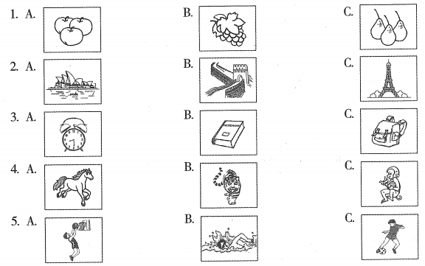
二、 对话理解(每小题1分》共5分)
本题共5个小题》每小题你躋听到一组对话和一个问题。请你从每小题所给的A、B.、C三 牛选疏曲选出一个最佳选项，并走答题卡上将检项涂黑。
6. A. A doctor. B. An engineer. C. A cook.
7. A. On Friday. B. On Saturday. C. On Sunday.
8. A. By subway. B. By car. C. By bus.
9. A. In the shop. B. In the school. C. In the bank.
10. A. He will spend time with family.
B. He will go camping with friends.
C. He will so to work this weekend.
三、本题你将听到一篇短文。请你根据短文内容和所提出的5个问题，从每小题所给的A、B、C 三个选项中，选出一个最佳选项，并在答题卡上将该项涂黑。
11、Who is Sam?
A. Mike9 s friend.
B. Mike's
C. Mike's cousin.
12、What did Mike think of Sam?
A. He was very smart.
B.He worked really
C. He always wanted to win.
13、How did Mike feel after the competition?
A. Tired.
B. Afraid.
C.Sad
14、Why did Mom have a talk with Mike?
A. To help him out.
B. To ask him to have a rest,
C. To teach him learning skills.
15、What does the story mainly tell us?
A. It’s important to have a dream.
B. Studying music brings happiness.
C. We should try to be the best ourselves.
四、本题你将听到一篇演讲词。请你根据所听内容，完成下面的句子，并将获取的信息填到答题卡相应的位置上。每空一词。
How to Spend the Time in Senior High School
How to Spend the Time in Senior High School
Speaker: Li Hua, a senior high school student from Grade 16.
Four pieces of advice:
Work hard
Senior high school also has teachers, 17. ，homework and exams.
Manage your time wisely
Try to finish your homework 18. and get enough sleep.
Don't compare yourself to others
Pay attention to your own work and don't 19. too much.
Stay active
You need to have your own plans. Don't be 20. .

笔试部分

五、补全对话（每小题1分，共5分）
下面是手机群聊的界面，请根据聊天内容，从方框内所给的选项中选出能填入空白处的最佳选项，并在答题卡上将该项涂黑。选项中有两项为多余项。
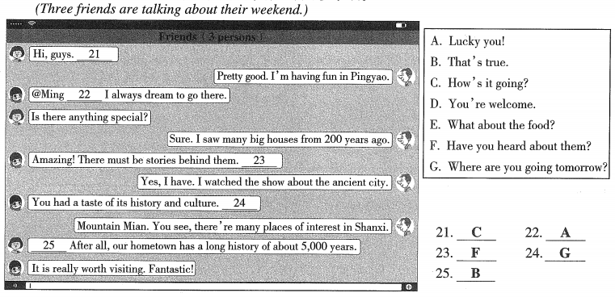

- 完形填空(每小题1分如共8分) 请阅读下面短文》理解其大意，然后从每小题所给的A、B. C三个选项中》选出一个能填 入空白处的最佳选项质并在答题卡上将该项涂黑。

Recently, I had a hard time working on a group project. My teacher put me with three classmates,but they didn't care about whether the work could be done. I had no 26 about what to do at all.
As we set the table for dinner, my mom noticed I was 27,“What's going on?” she asked.
“The others in my group aren't doing any work. It seemed that they didn't 28 to work on the projects,” I replied. “Do I have to do all the work for everyone if I don't want a 29 grade?”
“Well，” my mom said with a smile. “I doubt you＇re responsible （负责的） for everyone else＇s part. Why don't you 30 it with your partners?”
And at our next group meeting, I tried to share my worries in a friendly way. “Since we are working as a 31 ,we're depending on each other to do the best we can,” I said to them. “If anyone is having troubles,maybe we can talk about the 32 of solving them together. Let's work together and finish the task.”
33 , all my group members ended up doing their part. They didn't do things the way I would have. But I guess that's the deal with group projects.
26.A.need B. idea C.rule
27.A.worried B.bored C.excited
28.A.forget B.want C.wait
29.A.nice B.true C.bad
30. A. talk about B.learn from C.look for
31.A.class B.family C.team
32.A.ways B.habits C.lists
33.A.Suddenly B.Surprisingly C.Unluckily
- 七、阅读理解（这一部分共五篇短文，A至D篇每篇短文后有五个小题，E篇后有六个小题，每小题2分，共52分）
(A)
请阅读下面短文，从每小题所给的A、B、C三个选项中，选出一个最佳选项，并在答题卡上将该项涂黑。
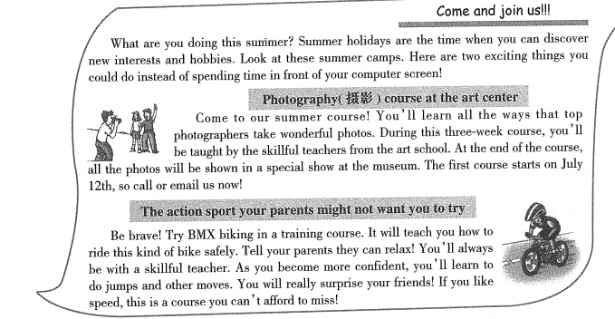
34. You can take the summer photography course
A. at the art school
B. at the art center
C. at the art museum

35. During the photography course, you will be able to
A. get a surprising gift
B.try different cameras
C. learn to take great photos

36. The bike training course gives you a chance to
A. enjoy speed
B. meet sports stars
C.relax with parents
37.Both of the summer camps
A. last for three weeks
B. hold special shows
C.have skillful teachers
38. The writer thinks students should on summer holiday.
A. make more friends
B. use the Internet properly
C. find new interests and hobbies

（B）

请阅读下面短文，从每小题所给的A、B、C三个选项中，选出一个最佳选项，并在答题卡上将该项涂黑。
Since tea spread from China worldwide, it has become one of the most popular drinks in the world. Different countries have their own tea cultures, like afternoon tea in England.
The tradition of afternoon tea is a very special part of English culture. The custom of drinking tea became popular in England during the 1660s. It was not until the mid-19th century that the idea of “afternoon tea"first appeared.
Afternoon tea is served in the mid-afternoon, between lunch and a late dinner. The idea came from Anna，the seventh Duchess（公爵夫人） of Bedford，in 1840． At the time， many families would eat a late dinner at about 8 p.m., which was one of only two main meals each day, and the other was a mid-morning meal.
With a long time between breakfast and dinner, Anna would become hungry around 4 o'clock in the afternoon. So she asked some tea, bread, butter and cakes to be brought to her room during the late afternoon. This became a habit of hers and she began inviting friends to join her.
Later, Anna continued it, sending cards to her friends asking them to join her for “tea and a walking in the fields”.
Others soon picked up on the idea. By the 1880s, afternoon tea became an event for many ladies. They would be dressed beautifully to be served in the sitting room between four and five o'clock, talking about the latest news,their daily life and fashion.
Today's afternoon tea is simpler than traditional afternoon tea. It is just a biscuit or small cake and a cup of tea. However, there is one thing that has never changed-the meaning of afternoon tea.
39. When did the idea of “afternoon tea” first appear in England?
A.In the 1660s.
B. In the 1880s.
C. In the mid-19th century.
40．In the third paragraph， what does the “two main meals” probably refer to（指）？
A. A lunch and a late dinner.
B. A breakfast and a mid-afternoon meal.
C.A mid-morning meal and a late dinner.
41. Why did Anna ask for tea and cakes in the afternoon at first?
A. Because she felt hungry.
B. Because she loved drinking tea.
C. Because she needed to treat friends.
42． What can we infer（推断）from the passage？
A. Afternoon tea has spread all over the world.
B.People used to drink tea more often than now.
C. Afternoon tea gives people a chance to communicate.
43. What is the best title of the passage?
A. Advantages of Drinking Tea
B. Development of Afternoon Tea
C. Different Tea Cultures in the World

（C）
请阅读下面短文，根据语篇内容，从方框内所给的选项中选出能填入空白处的最佳选项，使短文意思通顺，并在答题卡上将该项涂黑。选项中有一项为多余项。
Courage is often thought to be one of the important spirits everyone needs. Then what is courage? 44 One isn＇t necessarily born with courage， but one is born with potential（潜力）.Kids build courage as they are growing up.
Many people talk about connections between courage and fear. 45 If there is no fear,there is no need for courage. That is to say, courage is the ability to do what makes you feel afraid. Courage doesn't only mean great actions such as saving one's life or taking a big risk. 46 For example,we show courage when we raise our hand to answer a hard question during class or try a new sport.
Courage is in everyday choices we make. Can you be kind to the new kid in class? 47 _Or can you stand up for someone in need? Often, these things don't come with praise, but they need courage.
48 When we become brave enough to face failure, we'll be more willing to try new things and try again after we fail. Courage doesn't always shout. Sometimes courage is the little voice at the end of the day that says, “I'll try again tomorrow.”
A. You should learn to speak in public.
B. It is the ability to do something difficult.
C.Courage always stands side by side with fear.
D. Can you listen to the new person in your group?
E. Learning to fail is another important part of courage.
F. Courage also means the smaller actions of our everyday lives.

(D)
请阅读下面短文，根据语篇内容，在方框内的缩写文章中，填入与短文意思最符合的单词，并将答案写在答题卡相应的位置上。每空一词。
China impresses the world in the year 2022. In the past months,we have seen several important events that showed the world a strong China. Here we take a look back at them.
The Beijing 2022 Winter Olympic Games closed on February 20. Themed “Together for a Shared Future”， the Games drew attention of the world successfully. Athletes（运动员）competed bravely on the ice and snow,achieving their dreams. They encouraged people around the world with their spirits. Behind stage,Chinese food and culture impressed international athletes. Many shared photos and videos of their life on social media, telling Chinese stories to the world. Beijing 2022 gave the world a window on China.
While Beijing 2022 reflects rich Chinese culture, the great progress in science and technology shows the ability to innovate（创新）．On April 16，China welcomed three heroic astronauts home．After flying around Earth for six months, they came back home safely. During the stay in space,they gave lively science lessons from the Tiangong space station. That made millions of children fall in love with space science. What's more, on June 5, the Shenzhou XIV spacecraft rose into space and another three astronauts were sent into the space station. They will make a further step in the exploration（探索）of space.
All these great achievements show the power of China. We're proud of our country. We strongly believe that China will surely move forward to an even brighter future.

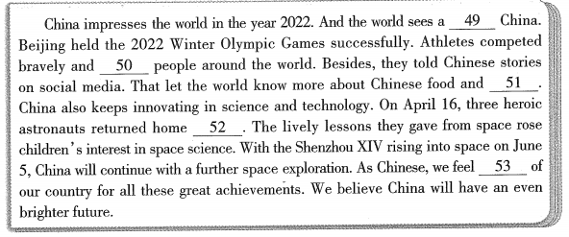
(E)
请阅读下面的非连续性文本，根据语篇内容，回答问题，并将答案写在答题卡相应的位置上。
Footprint means the influence that a person's or organization's activities have on the environment. Simply understanding it is very useful to us. (Let' s take the example of Mr. Brown's footprints.)
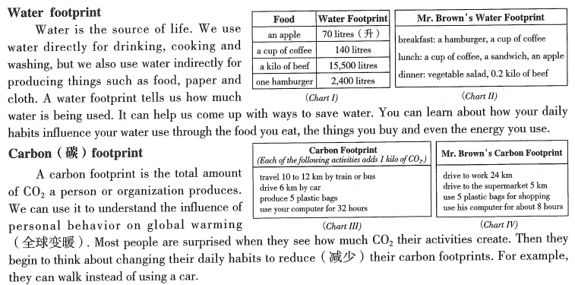
How to reduce your water footprint and carbon footprint to be greener
Tip 1:Save water and electricity
When you are at home, don't leave the water or lights on when you don't need it.
Tip 2:
Meatless Monday is popular with people who want to eat less meat. The production of meat uses lots of energy and produces lots of CO₂.
Tip 3:Buy less
The more we buy,the more we throw away later. Before you buy something, think about whether you really need it.
Everyone plays a role in making a greener Earth. If you know about your footprints well, you can think up more ways to protect the environment.
- What do we use water indirectly for?
55.How many litres of water are used for Mr. Brown's breakfast?
56. Why do we use carbon footprint?
57. What can Mr. Brown do to reduce his carbon footprint? Why do you think so?
58．What is the best subtitle（小标题）of Tip 2？
59. What's your understanding of footprint? How can you become “greener”?
八、词语运用（每小题1分，共20分）
A.请阅读下面短文，根据语篇内容，在空白处填入恰当的单词，使短文通顺、连贯，并将答案写在答题卡相应的位置上。每空一词。

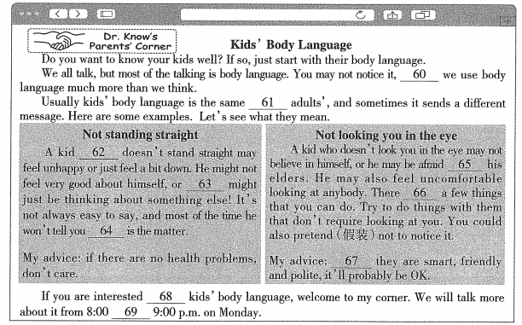
B.请阅读下面短文，根据语篇内容，用方框中所给词的正确形式填空，使短文通顺、连贯，并将答案写在答题卡相应的位置上。方框中有两个词为多余项。
do | she | clean | leaf | interest | meaning
ou | tell | have | thin | ha | celebrate
It was Friday afternoon. After getting off the school bus,Laura ran into the house 70
“How was school,Laura?”asked 71mom.
“It was great，Mom．Labor Day（劳动节） is coming． I am excited that I 72 no school next Monday！”
Laura was woken up early on Labor Day morning by her dad. He said that in honor of （ 纪念） Labor Day， the family planned 73 some cleaning. Laura couldn't believe it. She began to wonder if this was just a bad dream.
“Laura, your breakfast is ready. We have many_74 to do today. Let's get a move on,” said Laura's mom. Laura asked her parents, “Are you serious about working today? Isn't Labor Day a holiday?”
“Yes, Laura, it is,” replied her dad. “But your mom and I thought working hard today would make you realize why Labor Day 75_in the beginning.”
Laura disliked the plan, but she had no choice. First, she was asked to wash the breakfast dishes. After that,her dad 76 her to give their dog a bath. It was a hard task,which needed a lot of careful work. She began the work unhappily.
But things began to change as she was doing the chores. She found it was so 77 with so many soap bubbles（ 泡泡） when she brushed the dog. Then it was yard work and she helped to pick up sticks. When she finished her chores, Laura felt happy to see the yard looked much 78 than before.
Holidays are not necessarily for fun or rest. Doing something 79 can also get special pleasure. Maybe this is the spirit of Labor Day.
九、书面表达（共15分）请将短文写在答题卡相应的位置上。
有效的课后作业能激发学生的学习兴趣，丰富学习经历，提升综合素养，并在知识与生活之间架起一座桥梁。某校为减轻学生的负担，改进作业布置的方式，针对“你最喜欢的一种英语课后作业类型”，对1,267名学生进行了问卷调查，下图是相关的统计结果。

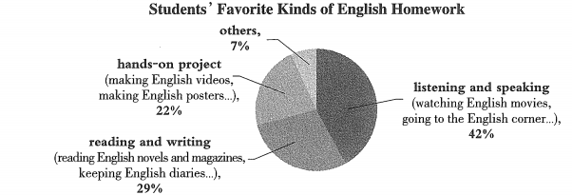
假如你是该校的学生，请你根据以上图表信息，用两段话写一篇短文。内容包括：
1．简要说明图表内容；
2．从图表中选出一种你最喜欢的作业类型，结合自己的经历，谈谈这种作业的好处。
要求：
1．词数不少于80词，首句已给出，不计入总词数；
2．文中不能出现真实的人名、校名；
3．参考词汇仅供参考。

