2022年浙江省初中毕业生学业水平考试(台州卷)
英 语 试题卷
亲爱的考生:
欢迎参加考试!请你认真审题, 仔细答题, 发挥最佳水平。答题时，请注意以下几点:
1. 全卷共10页。满分120分。考试时间100分钟。
2. 答案必须写在答题纸相应的位置上, 写在试题卷、草稿纸上无效。
3. 答题前, 请认真阅读答题纸上的"注意事项", 按规定答题。
卷一
说明：本卷共四大题，50小题，满分75分。
第一部分 听力部分
一、听力（本题有15小题，第一节每小题1分，第二、三节每小题2分；共计25分）
第一节：听小对话,从题中所给的A、B、C三个选项中选出最佳选项，回答问题。
1. What fruit does the girl like?
A. Apples. B.Bananas. C. Oranges.
2. When is Lucy’s birthday?
A. In April. B.In May. C. In June.
3. How will the weather be?
A. Sunny. B.Rainy. C. Snowy.
4. Why does the girl like art?
A. Because it’s easy. B. Because it’s relaxing. C. Because it s interesting.
5.Where are the two speakers probably talking?
A.In a hospital. B.In a museum. C.In a library.
第二节：听较长对话，从题中所给的A、B、C三个选项中选出最佳选项，回答问题。
听下面一段较长对话，回答第6~7两个小题。
6.Where is the man going?
A.To the hotel. B.To the bookstore. C.To the post office.
7.How long does it take to get there by taxi?
A.About 10 minutes. B.About 20 minutes. C.About 30 minutes.
听下面一段较长对话，回答第8~10三个小题。
8. What kind of music does the band play？
A. Rock music. B.Jazz music. C.Country music.
9. What instrument does Sarah play in the band？
A. The guitar. B.The drum. C.The piano.
10. How often did the band decide to give a concert？
A. Once a week. B. Twice a month. C. Three times a year.
第三节：听独白，从题中所给的A、B、C三个选项中选出最佳选项,回答问题。
11.When did the story happen?
A. Last spring. B.Last summer. C.Last autumn.
12.What did the speaker want to buy?
A.A storybook. B.A model car. C.A tennis ball.
13.Who bought the gift for the speaker?
A.His parents. B.His friends. C.His teachers.
14.Where was the gift bought?
A.At a store. B.In a museum. C.On the Internet.
15.Who may the speaker be?
A.A student. B.A teacher. C.A parent.
第二部分 笔试部分
二、完形填空（本题有15小题，每小题1分；共计15分）
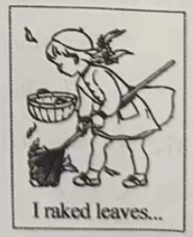阅读下面短文，掌握大意，然后从每题所给的A、B、C、D四个选项中选出最佳选项。
A few weeks ago, I found a perfect pair of shoes waiting for me at the store. They were green, blue, red and white, with just the right style. I could actually hear them calling __16__—”Leila，Leila，Leila!”
“Mom!” I pointed at the __17__ shoes.“Those are exactly the ones I need! Can I have them? Please?”
“Let’s see how __18__ they are,” said Mom.
My heart broke when we saw the price —$ 100! I knew Mom would __19__ buy them.
“I only have $25,” I __20__ what I was going to do.
Autumn was surely here. The days were __21__, and the leaves were falling from the
trees.I was looking out of the window one afternoon,watching the leaves falling in the yard. Suddenly I got a(n) __22__. I rushed downstairs.
“Mom,” I called into the living room. “I think I know __23__ I can make money to buy those shoes!”
Mom looked up from her book. “And how’s that, Leila?”
“People want their __24__ clean and tidy. I can rake(耙) leaves for them.”
A smile slowly spread across Mom’s face. “Now that’s a good idea!”
Each week, I __25__ leaves in people’s yards and put them in waste bins. It took five __26__ of hard work. I raked leaves until I got blisters(水疱) on my hands. My coats and trousers got dirty, but I didn’t __27__. As time went by, I was getting closer to my goal. In the end, I got enough __28__.
The big day finally came. Mom drove me to the store, and I walked __29__ into the shoe store. I found the shoes I’d wanted so much and tried them on in my size. They __30__ me perfectly! I finally had the exact shoes I wanted!
16. A. me B. you C. him D.them
17. A. big B. old C. ugly D.them colorful
18. A. funny B. heavy C. expensive D.different
19. A. always B. usually C. sometimes D.never
20. A. hated B. agreed C. refused D.wondered
21. A. hotter B. cooler C. wetter D.longer
22. A. gift B. idea C. email D.photo
23. A. how B. why C. when D.whether
24. A. stores B. rooms C. yards D.schools
25. A. talked about B. played with C. listened to D.picked up
26. A. days B. weeks C. months D.years
27. A. care B. decide C. follow D.answer
28. A. time B. money C. coats D.shoes
29. A. sadly B. angrily C. excitedly D.secretly
30. A. fit B. found C. helped D.missed
三、阅读理解（本题有15小题，每小题2分；共计30分）
阅读下面材料，从每题所给的A、B、C、D四个选项中选出最佳选项。
A
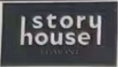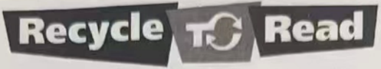
Become a waste fighter and help Captain Billy
re-love,re-use and re-cycle old plastic toys. You could
get some great books for free too! Cool eh?
Your old plastic toys were specially chosen and they brought you lots of fun. They can also be used over and over again. | Finished playing with your toys?Why not exchange them with friends? It helps to reuse your toys and pass on the fun. | Ask your school to join the Recycle to Read program. Drop off your broken plastic toys and get free books for your school.

All plastic toys collected in the Recycle to Read are made into great new products.
Visit www.wastebusters.club to find out more information.

31.What could you get if you help Captain Billy collect old plastic toys?
A.Some money. B.Some new toys.
C.Some free books. D.Some reusable bags.
32. What does the underlined word “It” in the poster refer to?
A. Choosing toys. B. Getting great books.
C. Dropping off old toys. D. Exchanging toys with friends.
33. You can _____ to find out more information about new products.
A. email Capital Billy B. ask your school
C. visit www.wastebusters.club D. call the story house magazine B
B
Dear Erik,
Surprise! I believe you didn’t expect a note from your mom in your lunchbox! How is your school day so far? I hope it is going well. You always do your best. I am proud of you!
Because I had to leave so early this morning, I wrote this note last night and put it into your lunchbox to wish you well on your speech today. With all of your amazing research, writing, and practice, you are going to do great!
I know that you get a little nervous talking in front of large groups—everybody does. But, just remember what you practiced and you just might forget about being nervous.
Here are just a few things to remember when you are giving a speech:
1.Make eye contact(眼神交流) with your classmates.
2.Speak clearly and slowly.
3.Look at your notecards only when you have to.
4.Enjoy yourself! Once you are in front of the class, pretend(假装) that you are a famous expert on your topic and everyone is listening carefully to your EVERY word.(I do that sometimes !)
Well, that’s all for now. I am thinking of you today and I know you will do great. Do your best and be brave like George Washington. He was an excellent choice for your speech.
Good luck Erik!
Maybe we can go out for ice cream after school!
Love,
Mom
34. Where did Erik probably find this note?
A. In his house. B. In his book.
C. In his wallet. D. In his lunchbox.
35.What was Erik mainly going to do in school that day?
A. To give a speech. B. To research his topic.
C. To have ice cream. D. To write some notecards.
36.Erik’s mother advised him to ______ to enjoy himself.
A. read his notecards B. look at his classmates
C. talk like a famous expert D. practice with his friends
37.We can infer(推断) that Erik’s mother was full of ______ from this note.
A. love B. fear C. thanks D. surprise
C
Space tourism(太空旅游业) is no longer a thing of science fiction. There are lots of companies planning to send people into space in the next few years. Space X is one of the most famous companies offering trips to space. So far, it has had over 100 customers. And in April, 2022, it sent 4 people into space. Now, what can space tourists do while in space? Here are some examples:
See the Earth from Space
Seeing the Earth from a distance has always been a dream. It gives most people a sense of both achievement and wonder(which is also why people climb the highest mountain and dive the deepest sea on the earth).
Stay in a Space Hotel
Hotels are directly connected with tourism,right? So if there’s space tourism, there might also be space hotels up soon. Orion Span has been planning to send tourists to stay in their “space hotel”,which would hold up to 6 people at a time.
Eat in Space
Eating is not easy in space. Even drinking water is difficult. Oh, a quick fact! You aren’t allowed to burp(打嗝) in space! Bubbles will come out of your mouth and it might be dangerous to leave them around.
Visit the Moon and Other Planets
Space tourism companies are racing to launch(发射) the first tourist flight to the moon. Although there might be along way to go before common people can step on the moon, we will probably see it in our lifetime. And who knows,maybe we’ll even see hotels on the moon.
With the industry rapidly developing, space tourism is around the corner, and it might come much faster than we think. Who knows what the future might be like? Will you be the next person to travel to space?
38.How many people did Space X send into space in April, 2022?
A. Three. B. Four. C. Five. D. Six.
39. Which of the following is TRUE according to the passage?
A. Orion Span has built six space hotels.
B. Eating in space is as easy as it is on the earth.
C. Seeing the earth from space is meaningless for most people.
D. It is possible for common people to visit the moon in the future.
40. The underlined words “around the corner” in the last paragraph probably mean “______”.
A.very slow B.very near
C.very difficult D.very traditional
41.The text is probably from the column(栏目) of _____ in a magazine.
A. Travel B. Health C. Sports D. Education
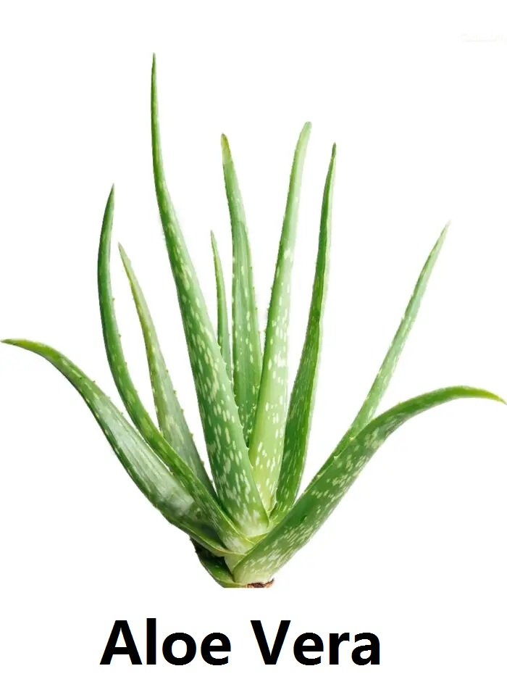D
①Would you like to get fewer colds and feel better? Would you like to have a taste of a special plant? Would you like to keep a plant with little care? An Aloe Vera plant could be just what the scientists may suggest!
②Growing Aloe Vera plants at home can make the air clean and fresh. Studies have shown that they give off oxygen(O₂) and take away harmful things from the air. With clean and fresh air, you are more likely to stay away from colds, sore throats and dry coughs. And even if you do get sick, Aloe Vera plants may help you get better from the illness faster.
③Did you know that Aloe Vera plants can be used as medicine? Aloe Vera gel(胶体) helps to deal with the pain of burns. And it also helps with itchiness(痒) caused by insect bites. To get this gel, just cut off a part of the plant, peel it, and put the gel on the affected skin(患处). This easy-to-get and safe-to-use medicine is available to you all year round.
④Apart from medical use,Aloe Vera plants are also popular in food industry. Whether you are interested in Aloe juice or crazy about Aloe yogurt, you’ll easily find them in the supermarket. Aloe Vera can also go with other vegetables to make a safe dish on your dinner table.
⑤ ▲ They like dry,warm air with bright light,so they grow best when placed near a window. Aloe Vera plants are able to keep water in their leaves. So, they do not need to be watered so often as most houseplants. Just wait until the earth is completely dry before you water them. When watering, make sure the earth is wet enough so that it can last for a long time. That’s all you need to do to to take care of an Aloe Vera plant. Isn’t it the perfect plant for lazy and forgetful gardeners
42. In Paragraph 1, the writer leads into the topic by _______.
A. telling stories B. listing numbers
C. giving examples D. asking questions
43. What are the uses of Aloe Vera gel as medicine in Paragraph 3?
a. It’s good for eyes. b. It stops nosebleed.
c. It helps with the itchiness. d. It helps people lose weight.
e. It deals with the pain of burns.
A.c,e B. a,b C.b,d D. a,d
44.Which of the following can be the best to fill in “ ▲ ” in Paragraph 5?
A. Aloe Vera plants help you improve memory
B. Aloe Vera plants are very easy to take care of
C. Aloe Vera plants can serve as a delicious dish
D.Aloe Vera plants are good-looking houseplants
45. The structure of the passage may be ______.
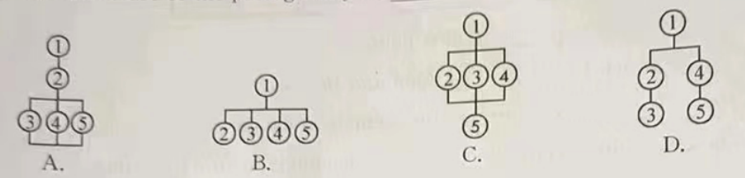
四、任务型阅读（本题有5小题，每小题1分；共计5分）
阅读以下对话，从方框内的六个选项中选择五个填入空白处（其中一项是多余选项），使对话通顺、合理，意思完整。一空一句。
Ed:Hi, Shelly! __46__What’s the matter?
Shelley:I can’t find my school bag! It’s got all my books in!
Ed:Oh,no!__47__
Shelley:Umm,I went to the sports center with my friends.After that,we went to buy a drink, and then we went to the park.
Ed:__48__
Shelley:I’m not sure. I was on my way home when I realized I didn’t have it.I went back to the park to look for it. __49__ I don’t know what to do.
Ed: Don’t worry! Perhaps a friend saw it and took it home.
Shelley: No, I don’t think so.__50__
Ed:Well, maybe you left it in the shop. Let’s go and ask if it’s there.
Shelley: OK. I hope so!
A. But I couldn’t find it!
B. Sounds interesting.
C. Where did you go after school?
D. You look upset.
E. Did you leave it in the park?
F. No one called me.

卷二
说明：本卷共三大题，26小题；满分45分。
五、词汇运用（本题有15小题，每小题1分；共计15分）
A.用方框中所给单词的适当形式填空，每词仅用一次。
third above quickly ours raise
51. This is not our classroom. _____is next door.
52.Time goes _____ when I read The Old Man and the Sea.
53. Last week we _____ money to protect the animals in danger.
54.The little boy was excited while flying _____ the clouds for the first time.
55Father’s Day is on the Sunday in June.Remember to show love to your father.
B.根据短文内容和所给中文提示，在空白处写出单词的正确形式。每空限填一词。
My heart is filled with love.Recently, I’m so __56__(感激的) for the support of a very dear friend of mine. With his help,I can realize my dream of making a kind act. It __57__(带来) me more power in my life.
We live in a small African city. As you know, people are __58__(贫穷的) and it’s hard for them to find jobs. I’ve been looking forward to opening a __59__(汤) kitchen for many years.I hope to help the __60__(当地的) people in need. My friend helps me create a Facebook __61__(页面) called Sunshine.On it, we usually __62__(分享) our kind activities with our friends. These days, I’m making hearty food while my friend is handing our clothes to the homeless. There are so many people living on the __63__(街道), which shocks me a lot.
We want to __64__(邀请) more people to join us. The act of love by giving has touched my heart greatly. Sometimes I’m tired at the end of the day, but I __65__(仍然) love the journey I’m on. Because of the project, my life becomes so meaningful. I just know what I’m doing now may make a difference to some people’s life.
六、语法填空（本题有10小题，每小题1分；共计10分）
阅读下面短文，在空白处填入一个适当的词，或填入括号中所给单词的正确形式。
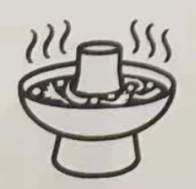As a foreigner, the first time I ate hot pot was in Chongqing, China. The hot pot restaurant was one of the largest and __66__(busy) places in the city. In the restaurant, hundreds __67__ people were crowded into one large room. My friend and I sat at a table with __68__ large pot in the middle. It was an amazing experience. I __69__(real) couldn’t forget it.
Today, the hot pot is one of the most popular forms of coking in China, and nearly every town and city has some hot pot __70__(restaurant). Some people might ask how hot pot becomes so popular. With a hot pot, you can __71__(put) in any food that you like. The same pot can serve any number of different meals to the people sitting around the table. Everyone can eat as much __72__ they want and no one is left out. This __73__(be) one of the values of Chinese culture. Finally, not only does hot pot taste wonderful, but it is the perfect way __74__(spend) time with others.
In China, people often joke that there’s no problem that a hot pot can’t solve. Over a hot pot, people can talk about not just food, but friendship. The food may son be forgotten, __75__ the friendship will stay with us forever. Even today, I remember all the good times I spent with my friends in Chongqing.
七、书面表达（本题有1小题；共计20分）
76.毕业之际，学校英文报将举行以“My dream job”为题的征文比赛。请你根据自己的理想，选择下表中一个职业或自行确定另一个职业写一篇英语短文，向校英文报投稿。
内容要点 | 参考词汇
What do you want to be when you grow up | a teacher | a scientist
Why do you want to be a(n)…? | ●be good at communicating  ●work with children | ●be interested in science  ●invent new products
How are you going to do that? | ●get a good education  ●learn how to teach children | ●study science hard  ●do scientific research
Where are you going to work? | ●… | ●…
When are you going to start? | ●… | ●…
注意：(1)文中必须包括所给的内容要点，可适当发挥，参考词汇仅供选择使用；
(2)文中不能出现真实的人名、校名等相关信息；
(3)词数80～100。
My dream job
________________________________________________________________________________________________________________________________________________________________________________________________________________________________________________________________________________________________________________

