2022年岳阳市初中学业水平考试试卷
英 语
温馨提示：
1．本试卷共两部分，76小题，满分120分，考试时间90分钟；
2．本试卷分为试题卷和答题卡，所有答案必须填涂或填写在答题卡规定的答题区域内；
3．考试结束，考生不得将试题卷、答题卡、草稿纸带出考场。
Good Luck to all of you !
第一部分 听力部分（共三节，满分20分）
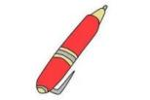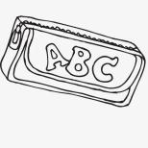第一节 图片理解 从每小题所给的三幅图中选出与你所听到的对话内容相同或相近的图画，每段对话读两遍。
- A. B. C.
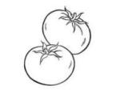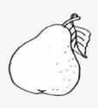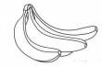
2．A. B. C.
3．A. B. C.
4．A. B. C.
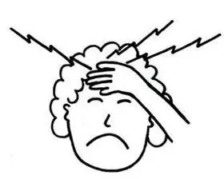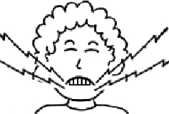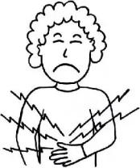
5．A. B. C.
- 对话理解 根据你所听到的对话内容，选择最佳选项回答问题，每段对话读两遍。
听第6至第10段对话，回答第6～10小题。
6．What’s the woman’s first name ?
A. Linda. B. White. C. Gina.
7．How much is the purple skirt ?
- $15. B. $40. C. $45.
8．What time will they go shopping this afternoon ?
A. At 3:30. B. At 3:15. C. At 3:45.
9．What was Mike doing when the girl called him ?
A. Watching TV. B. Taking a shower. C. Drinking coffee.
- Who is Jenny’s sister?
- The tall girl with curly hair.
- The heavy girl with straight hair.
- The short girl with blonde hair.
听下面一段对话， 回答第11、12小题。
- How far is it from Tom’s home to Animal Helpers?
- 4 kilometers. B. 5 kilometers. C. 6 kilometers.
- How does Tom go to Animal Helpers in Yueyang?
- By bus. B. By bike. C. On foot.
听下面一段对话，回答第13～15小题。
- Why is Kim angry with his grandfather?
- Because grandfather read Kim’s diaries.
- Because grandfather expected to look after Kim.
- Because grandfather shouted at Kim.
- What will Kim do to solve the problem?
A. Talk with others. B. Keep a diary. C. Write his grandpa a letter.
- How old is Kim’s grandfather?
A. 68. B. 70. C. 87.
第三节 短文理解 根据你所听到的短文内容，回答第16～20小题，短文读两遍。
- What did they see along the way?
- Flowers and trees. B. Pandas. C. Gifts.
- How long did it take them to arrive at the top of Yun Mountain?
- Half a day. B. Half an hour. C. An hour.
- How many pandas were there in the zoo?
A. 2. B. 3. C. 4.
- How did they feel about pandas?
A. Beautiful and lazy. B. Lovely and cute. C. Scary and ugly.
- Whom did the writer buy the toy panda for?
A. The writer’s cousin. B. The writer’s sister. C. The writer’s classmate.
第二部分 笔试部分（共三节，满分100分）
- 知识运用（共两部分，20小题，21～40小题，每小题1分，共20分）
- 单项填空 从A、B、C三个选项中选出一个最佳答案。
- Gu Ailing is _____ excellent sports star who made a great success in the Beijing 2022 Winter Olympic Games.
- a B. an C. the
- Even if we are in Grade 9, it's necessary for _____ to go to bed early and get up early.
A. we B. us C. our
- So many young people regard _____ as the most delicious drink.
A. salad B. porridge C. milk shake
- I will return it to the library _____ I finish reading Little Women.
A. no longer B. as soon as C. so that
- With the development of 5G technology, our daily lives have become _____.
A. more and more convenient B. the most convenient C. convenienter and convenienter
- The Monkey King is not a normal monkey, he can ____ himself ____ different animals and objects.
A. turn...off B. turn ... up C. turn... into
- Many students practice _____ in the morning because of the P.E. exam.
A. run B. running C. ran
- The Communist Party of China’s 20th National Congress (中共二十大）___ in autumn this year.
A. was held B. is held C. will be held
- They wonder ____________________.
A. if robots will think like a human in 25 to 50 years
B. if will robots think like a human in 25 to 50 years
C. when robots will think like a human in 25 to 50 years
- — Long time no see, Angela. How’s it going? — __________, thank you.
A. It doesn’t matter B. The same to you C. Pretty good
B)完形填空 通读全文，掌握其大意，然后从各题所给的A、B、C 三个选项中选出一个正确答案。
FIFA World Cup is one of the biggest sports events in the world. It 31 every 4 years. The first World Cup was in 1930. It has a history of over 90 years. During the World Cup, 32 fans watch the games and cheer for their favorite teams or players. We have known some famous football players from the football competitions, such as Beckham, Messi, and Figo. They have excited football fans for many years. The World Cup 33 the best chances for football players around the world. The winners can get not only 34 but also respect(尊重).
The 2022 World Cup will start on November 21st and 35 on December18th. The competition is going to last(持续) 36 days. To avoid the high 37 in Qatar(卡塔尔), the games will come in winter 38 summer. Gianni Infantino, FIFA’s president (国际足联主席) said, “This is a good decision, the 39 temperature in Qatar is up to 45℃. It’s too hot for players to compete.” The true spirit of the 2022 World Cup is “Where there is life, there is struggle(奋斗).” It’s sure that every football player will try 40 best to achieve their goals.
If you have time, if you love soccer, why not come to Qatar to enjoy the exciting football event?
- A. takes off B. takes a walk C. takes place
- A. few B. little C. quite a few
- A. has agreed B. has refused C. has provided
- A. silence B. honor C. mistakes
- A. end B. begin C. cross
- A. 8 B. 18 C. 28
- A. price B. heat C. speed
- A. instead of B. in total C. in front of
- A. deepest B. highest C. widest
- A. their B. theirs C. them
- 阅读技能（共四部分，20小题，每小题2分，共40分）
- 选择答案 阅读下列材料，从A、B、C 三个选项中，选择最佳选项回答问题或完成句子。
(Ⅰ)
APPs | Functions(功能) | Launch (推广)Time
Alipay  Alipay Network Technology CO.,LTD | ＊Paying for bills(账单)  ＊Shopping online  ＊Booking (订购)tickets | In 2004
Wechat  Tencent Technology Company | ＊Chatting(交流)with others  ＊Sending red packets(包)  ＊Sharing locations  ＊Making voice or video calls | In 2011
Himalaya  Shanghai Himalaya Technology CO.,LTD | ＊Listening to many radio programs  ＊Listening to audio books (有声书籍） | In 2013
41．Alipay is used for .
A. listening to many programs B. paying for products C. chatting with others
42．When was Wechat put to use?
A. In 2004. B. In 2011. C. In 2013.

(Ⅱ)
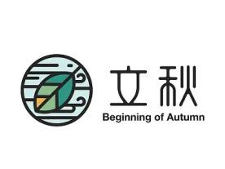
Spring Equinox
The 4th term
March 20th～April 5th

Grain in Ear
The 9th term
June 5th～June 20th

Beginning of Autumn
The 13th term August 7th～August22nd

Greater Cold
The 24th term
January 20th～February 2nd

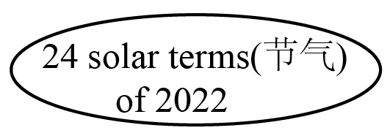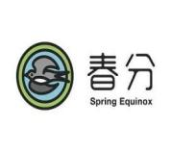
Everything begins to grow and flowers come out. Some birds fly back to the north. People always fly kites and go climbing.

It’s a long period of continuous (持续不断)rainy and cloudy weather. Farmers are busy sowing (播种) and working in the fields.
It is snowy and cold.
People wear thick clothes to keep warm. Children often make snowmen and do some winter sports like ice skating.

The leaves of trees start to fall, as the saying goes “one leaf falls, autumn arrives.” people can feel that the wind is getting cool.

43．Spring Equinox is the best time to .
A. fly kites B. pick up leaves C. make snowmen
44．How’s the weather during Grain in Ear?
A. Sunny and hot. B. Rainy and cloudy. C. Snowy and cold.
45．Which solar term is the last one of all the solar terms?
A. Spring Equinox. B. Grain in Ear. C. Greater Cold.
- 判断正误 阅读下面的材料，判断下列句子是否符合短文内容。符合的填涂“T”,不符合的填涂“F”(T=True, F= False)
There are three characters on everyday stage. I’m the main character COVID-19 vaccine (新冠疫苗), you are my partner nucleic acid test (核酸检测). We have an enemy, his name is COVID-19 (新型冠状病毒).
Nowadays, COVID-19 is spreading around the world. He is very tiny but harmful, people can’t see him with their eyes. He can spread from one person to another easily and quickly. People are afraid of him because he can make them sick and have a fever. That’s why people stay at home and hide from him.
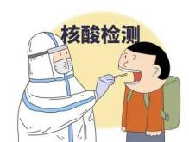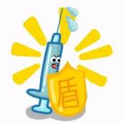Then I’m coming, my name is vaccine, everyone needs me because there is no special medicine to treat COVID-19. I can help people to stay away from the virus(病毒). People can get me for free, if they get me twice, they will have green health codes(健康码) with a needle(针) hat. Now people are supposed to get me a third time in the hospital. This can lower(降低) the risk of getting virus. With the third vaccine, people’s green health codes put on a shield(盾牌), it’s also a passport to enter public places.
You are my best partner, nucleic acid test. People just need to stand there and open their mouths to take you. Doctors and nurses are working hard to check whether people have COVID-19 or not. They all think you are the most useful way.
So far, you and I have performed pretty well on this stage. Thanks to our strong country, we will pull together to make sure people can live a normal and safe life.
46．COVID-19 is so small that people can’t see him.
47．Getting vaccines isn’t helpful to stop COVID-19 from entering human body.
48．It costs people much money to get COVID-19 vaccines.
49．Nucleic acid test is the partner of COVID-19.
50．To check if they have COVID-19, people need to take nucleic acid tests.
- 补全短文 根据短文内容，从短文后的选项中选出能填入空白处的最佳选项。选项中有两项为多余选项。
“A child with a mother is like a treasure.” 51
When you were a baby crying all night, your mom sang to you and stayed by your side. When you were tired, 52 When you fell and hurt yourself, she gave you a hug and lifted you up. When you didn’t get what you wanted, when you were sad, when... your mother was always there to help you. She is a mother who is common and wants nothing in return at all.
Among all the mothers, we are deeply moved by the two mothers . Wang Yaping is the first Chinese woman to live in the Tiangong station and the first female(女性) Chinese spacewalker(太空行走者). She is also a 6-year-old girl’s mother. Before setting out, she promised to pick a star for her daughter. Six months later, Wang Yaping came back and told her little daughter, “Mom has returned after reaching for the stars.” 53 She is an inspiring(鼓舞人心的) and unusual mother. Zhang Guimei is the headmaster of Huaping Girls High School in Lijiang, she went out of her way to raise money so that she set up this school. 54 Over the past 13 years, she has sent 1,800 girls to university. Zhang Guimei’s effort and love have changed their lives. 55 she is a selfless(无私的) mother to these girls.
Mother plays an important role in our lives. All the mothers have one thing in common: Full love in their eyes, bright light in their hearts.
- she gave you warm arms to sleep in.
- She succeeded in achieving her promise.
- However, Zhang Guimei raised money for her own child.
- This song shows that mother means the whole world to her child.
- Although she doesn’t have her own child,
- This song brings friends closer together.
- It has offered free education to girls in the mountains.

D) 阅读表达 阅读短文，根据短文内容，简要回答下列问题。
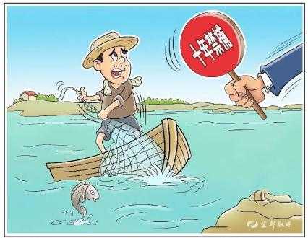Recently, a father called Daming and his son Dongshun’s photos became hot all over China. In the photos, while they are working on the boat on Dongting Lake, lots of fish are jumping into the fish bin(鱼舱).
Dongting Lake is the second freshwater(淡水) lake in China, it’s home to nearly 400 kinds of fishes. But in the past, people threw litter and factories put waste water into the lake. Even worse, a large number of fish were caught by fishermen. Because of pollution and overfishing (过度捕捞), the Yangtze River was in great danger. For example, the Chinese paddlefish(中华白鲟) disappeared 2 years ago. Daming used to make a living by fishing near Dongting Lake. However, life was gradually becoming difficult for Daming and other fishermen. The more times they went to fish, the fewer fish they could get.
In January, 2020, the government called for a 10-year fishing ban(禁渔令), covering 332 conservation areas(保护区) in the Yangtze River. Dongshun has worked with his father as a lake ranger(巡湖员) for almost 3 years. This job helps him understand how important it is to protect Dongting Lake. “I think this job is meaningful.” he said, “ As the wind is blowing gently, fish are swimming happily. What a beautiful scene! The fishing ban will lead Dongting Lake to a better future.”
56. Why was the Yangtze River in great danger in the past from the passage?
57. How did Daming use to make a living?
58. What did the government call for in January, 2020?
59. What is Dongshun’s job now?
60. Does Dongshun know the importance of protecting Dongting Lake?
第三节 写作技能（共三部分，16小题。61~70小题，每小题1分；71~75小题，每小题2分；76小题20分，共40分）
- 阅读填空 根据短文内容，在文中空格处填上一个恰当的词，使短文完整、通顺。
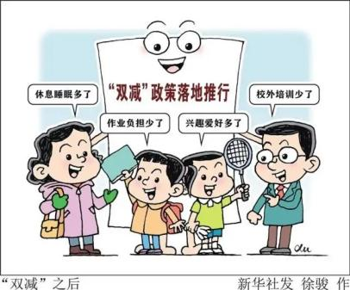How does the tea plant grow? This term, some students got their answers in the school’s rooftop(屋顶) garden. Many schools have built small gardens on their teaching building’s rooftop. Some students planted tea plants there. While taking 61 of tea plants, they also did experiments to learn more about tea.
How to 62 egg soup and sandwiches? Some students learned to cook in an after-school cooking club. To parents’ 63 , their kids could cook some simple dishes in a short time.
In the past, Chinese children were sometimes busier after school 64 they had to take so many after-school classes. Now, students join all kinds of clubs. Why do students have free time to 65 up their hobbies? Because China has introduced the “double reduction” policy(双减政策). It hopes to ease(减轻) students’ learning burden(负担) 66 reducing homework and after-school classes.
Students’ lives have changed a lot since the policy was carried out. On the one hand, their homework is clearly 67 than before, they aren’t encouraged to buy workbooks(练习册) any more. Teenagers have more chances to get knowledge from the real life. This is a much better way than just hitting the books. On the other hand, students spend more time 68 after-school clubs, they get lots of life skills from these colorful clubs and have enough time to relax and think for 69 . It’s believed 70 the “double reduction” policy makes a difference to students’ lives.
B)翻译语篇 阅读下面的短文，将文中的划线部分译成汉语或英语。
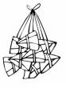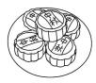Different Chinese festivals have their own special foods. Dumplings, mooncakes, zongzi and sweet dumplings(汤圆) are the most popular.
※ Zongzi 71. Zongzi is the typical food of the Dragon Boat Festival . On that day, people often make zongzi by hand. They put pork , red dates (红枣)，beans into sticky rice(糯米). There are boat races in Miluo River every year. Some old people put zongzi in Miluo River to honor the ancient poet(诗人)—Qu Yuan.
※ Mooncakes 72.月饼是满月的形状。 On the Mid-Autumn Festival, the moon rises in the sky, mooncakes and fruits are laid out in the garden. All the family sit around a table, admire the bright and round moon, enjoy mooncakes, listen to the traditional folk stories and pray(祈祷) for family’s happiness and peace.
※Dumplings Dumplings are China’s traditional food and local snacks. They look like gold or silver ingots(锭). They can be boiled, steamed(蒸) and pan-fried(煎)。It’s a traditional custom that family members make and eat dumplings on the Spring Festival. People always hide a coin in one of the dumplings. 73.吃到有硬币的饺子的人是一个幸运儿。
※Sweet dumplings Sweet dumplings are a must-have on the Lantern Festival. We always make sweet dumplings good-looking, just like small balls which give us a big smile. We usually eat sweet dumplings and guess lantern riddles(谜语) on this festival. 74. Most of us like sweet dumplings because they remind people of many soft and sweet memories.
No matter how far away they are from home, the food is like a bridge between family members. The taste of food means the taste of home. 75. Chinese get a strong feeling, there is “ no place like home.”
C)作文
76.某英语网站开展关于“How to Improve Myself”的征稿活动，倡导同学们提升自我，努力成为“终生运动者，责任担当者，问题解决者，优雅生活者”，请根据以下图示内容积极投稿。
Voices from “YES” | Voices from “NO”
……  每天锻炼一小时  兴趣爱好广泛  直面问题  对家庭，对自己负责任  Word Bank  be responsible for  depend on  take up  run away from  be in the face of  be interested in  … | ……  逃避问题  过于依赖父母  待在家里玩游戏  对任何事情毫无兴趣
要求：1.词数80～100；
2.请根据以上提示信息，结合实际情况叙述，可适当发挥；
3.文稿中不得出现真实的人名、校名；
4.字迹工整，语言流畅，表达正确，逻辑清晰。
How to Improve Myself
Life is really a long lesson, so I have to improve myself.

2022年岳阳市初中学业水平考试
英语参考答案及评分标准
第一部分 听力部分
1-5 CACAB 6-10 ACABA
11-15 CBACB 16-20 ABABB
第二部分 笔试部分
第一节 A) 单项填空 21-25 BBCBA 26-30 CBCAC
B) 完形填空 31-35 CCCBA 36-40 CBABA
第二节 A) 选择答案 41-45 BBABC
B) 判断正误 46-50 TFFFT
C) 补全短文 51-55 DABGE
D)阅读表达
56. Because of pollution and overfishing.
57. By fishing./ He made a living by fishing./ He made a living by going fishing.
58. A 10-year fishing ban.
59. A lake ranger.
60. Yes, he does.
第三节 A)阅读填空
61. care 62. make 63. surprise/imagination/joy/satisfaction/happiness
64. because/as/since/for 65. take 66. by/through
67. less 68. joining/on 69. themselves 70. that
B) 翻译语篇
71. 粽子是端午节的代表（性）食物.
粽子是端午节的典型食物.
72. The mooncake is in the shape of a full moon.
Mooncakes are in the shape of a full moon.
73. The person who eats the dumpling with a coin is a lucky guy.
The person who eats the dumpling with a coin is a lucky one.
The person that eats the dumpling with the coin is a lucky dog.
The person that eats the dumpling with the coin is a lucky person.
74. 我们中的大多数人喜欢汤圆因为它们使人们想起许多柔软而甜蜜的回忆。
我们中的大多数人喜欢汤圆因为它们使人们想起许多温馨而甜美的回忆。
75. 中国人有一种强烈的感觉：千好万好不如自己的家好。
中国人有一种强烈的感受：金窝银窝不如自己的狗窝。
C)作文
评分标准：
第一档（20分）：要点齐全，表达准确，语意连贯，结构完整，有适当发挥，无任何语法错误。
第二档（16～19分): 要点基本齐全，语言基本通顺，有适当发挥，有1～3个语法错误。
第三档（12～15分）：有较多相关内容，语言达意，有4～5个语法错误。
第四档（8～11分）：只有一部分相关内容，有一些语法错误。
第五档（1～7分）：词不达意，错误较多或只有一些与题目相关的单词、短语。
第六档（0分）:只有与题目内容完全无关的单词或句子。
2022年岳阳市初中学业水平考试试卷
英语听力材料
- 图片理解 从每小题所给的三幅图中选出与你所听到的对话内容相同或相近的图画，每段对话读两遍。
- M: I know you have a blue pen, is this yours?
W: Yes, it’s mine.
- M: Gina, would you like some tomatoes?
W: Yes, please.
- M: My birthday is coming soon, are you still here in September?
W: Yes, I’ m looking forward to your birthday party.
- M: Excuse me, I’m new here. Could you please tell me the way to the museum?
W: Sure, just turn left at the first crossing. It’s on Guangming Road.
- M: You seem so tired, Alice. Are you OK?
W: I have a headache and I can’t move my neck.
- 对话理解 根据你所听到的对话内容，选择最佳选项回答问题，每段对话读两遍。
听第6至第10段对话，回答第6～10小题。
- M: Good afternoon, are you Mrs. White?
W: Yes, I’m Linda White. My first name is Linda, my last name is White.
- M: You are so beautiful in the purple skirt.
W: Thanks. It’s made of silk. It cost me＄45.
- W: How about going shopping at 3:30 this afternoon?
M: At 3:30? OK, no problem.
- W: Hey, Mike. I called you last night, but you didn’t pick up the phone.
M: Oh, I’m sorry. I was taking a shower at that time.
- M: What a nice photo, Jenny! Is the tall girl with curly hair your sister?
W: Yes, she is my sister, Susan.
听下面一段对话，回答第11、12小题。
W: I hear you often go to Animal Helpers in Yueyang on weekends, right?
M: Yes, I go there to help out as a volunteer.
W: Is it far from your home, Tom?
M: Yes, it’s 6 kilometers.
W: Wow! That’s far, how do you go there?
M: By bike. Riding a bike is good for my health.
W: That sounds great! May I join you?
M: Of course. Let’s meet at the supermarket near my home next Sunday!
W: OK, catch you then.
听下面一段对话，回答第13～15小题。
W: Kim, you look unhappy, what’s wrong with you?
M: I’m angry with my grandpa. He looked through my schoolbag without asking me first. He read my diaries.
W: Hmm...That’s not very nice. Does he often do this?
M: Yes, what should I do?
W: Why don’t you sit down and communicate with him?
M: I don’t know what to say.
W: You could write him a letter and tell him what you think.
M: It’s a good idea, I’m good at writing letters.
W: He is 70 years old, but I think he should say sorry to you.
M: You’re right. Thanks for your advice.
W: Hope things work out.
- 短文理解 根据你所听到的短文内容，回答第16～20小题，短文读两遍。
Last Saturday, our class went on a school trip. We visited Yun Mountain. We started our trip at 8:00 in the morning. Everyone in our class took a bag with some desserts and water. Along the way, we saw some beautiful flowers and green trees. Half an hour later, we got to the top of the mountain. From here, the city looked wonderful. We had a rest and drank some water.
Then we went to the zoo happily, we saw different kinds of animals. My classmates and I liked pandas best. There were 2 pandas called Huanhuan and Panpan. When we arrived, the 2 pandas were awake and ran over to the panda keeper with excitement. They were so cute and lovely. The panda keeper washed, fed and played with the two pandas. We wanted to feed them as well, but the keeper warned us not to do that. We took some photos of pandas with our mobile phones. I put the most beautiful one online to share with others.
After that, I went to the shop and bought some gifts for my little sister. She liked the toy panda very much. All in all, it was an interesting day.

